CEBU INSTITUTE OF TECHNOLOGY
UNIVERSITY

COLLEGE OF COMPUTER STUDIES

Software Design Description
for
MetaDoc: Google Drive-Integrated Metadata Analyzer for Academic Document Evaluation

Proponents: Edgar B. Quiandao Jr.
Paul G. Abellana
Miguel Ray A. Veloso
Mark Christian Q. Garing

Adviser: Mr. Ralph Laviste & Dr. Cheryl Pantaleon
Signature

Change History

Preface

Table of Contents

1. Introduction 6
1.1. Purpose 6
1.2. Scope 6
1.3. Definitions and Acronyms 6
1.4. References 6
2. Architectural Design 7
3. Detailed Design 8
Module 1 8
Module 2 9

Introduction

Purpose
The purpose of this Software Design Document (SDD) is to provide a detailed architectural and component-level blueprint for the development of MetaDoc. This document translates the requirements defined in the SRS into technical specifications, detailing the system structure, data design, user interfaces, and logic flows required for implementation. It serves as the primary reference for developers to build the middleware system, ensuring compliance with the functional and non-functional requirements

Scope

Definitions and Acronyms

API: Application Programming Interface
DTO: Data Transfer Object
FK: Foreign Key
Gemini: Google's multimodal AI model
JSON: JavaScript Object Notation
NLP: Natural Language Processing
ORM: Object-Relational Mapping (SQLAlchemy)
PK: Primary Key
SRS: Software Requirements Specification
TLS: Transport Layer Security

References
1. MetaDoc SRS: Software Requirements Specifications for MetaDoc, 2025.
2.Google Drive API Documentation: https://developers.google.com/drive/api
3.Data Privacy Act of 2012: Republic Act No. 10173

Architectural Design

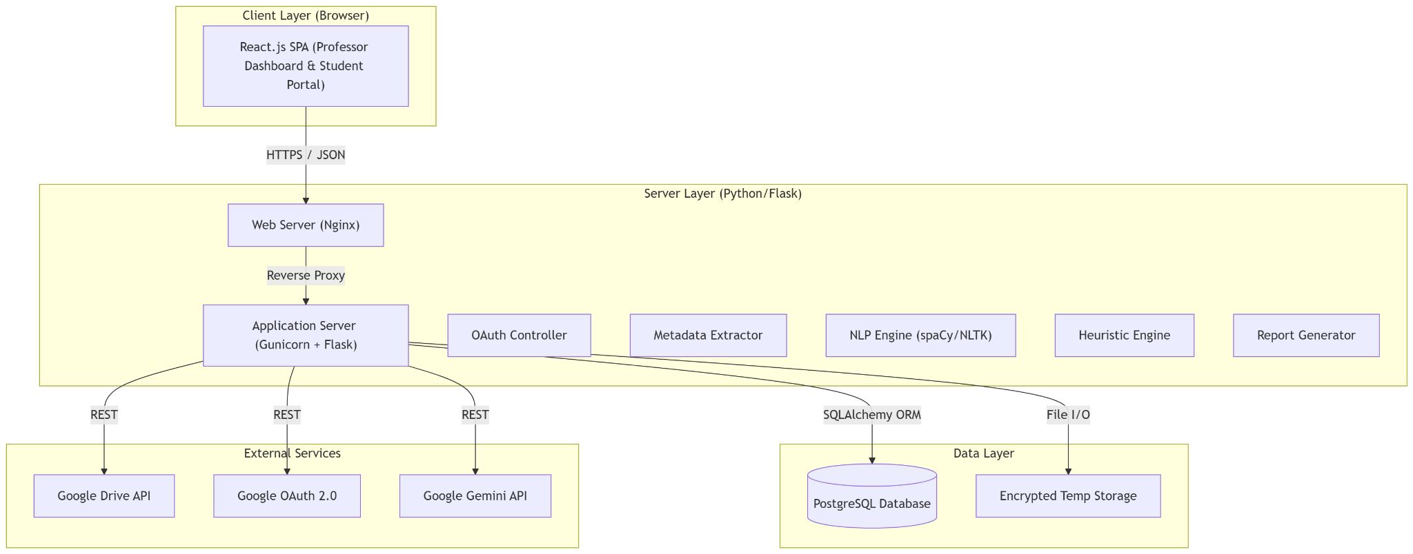
The system follows a Client-Server Architecture utilizing a RESTful API pattern.
2.1 System Block Diagram
Frontend: Developed using React.js for a dynamic, responsive user interface.
Backend: Built with Python Flask, utilizing SQLAlchemy for ORM.
Database: PostgreSQL is selected for its robustness and JSON support for storing analysis reports.
Security: All communications utilize TLS 1.3

Detailed Design

Module 1: File Submission, Retrieval, and Validation

1.1 Transaction: Submit File for Analysis (Upload / Drive Link)

Traceability: Implements M1.UC01
User Interface Design (Front-end)

Component Name: SubmissionForm.jsx

Description: A form allowing file drag-and-drop or Drive Link input. Includes client-side validation for file type (.docx) and size (<50MB).

Type: React Functional Component.
Back-end Component(s)
- Component Name: SubmissionController.py (/api/v1/submit)
- Description: Receives the POST request. If upload, validates and saves to temp storage. If link, invokes DriveService.
- Type: Flask Route Handler.
- Component Name: DriveService.py
- Description: Handles communication with Google Drive API to validate links and download files using the service account.
- Type: Service Class.

Object-Oriented Components
- Class Diagram:
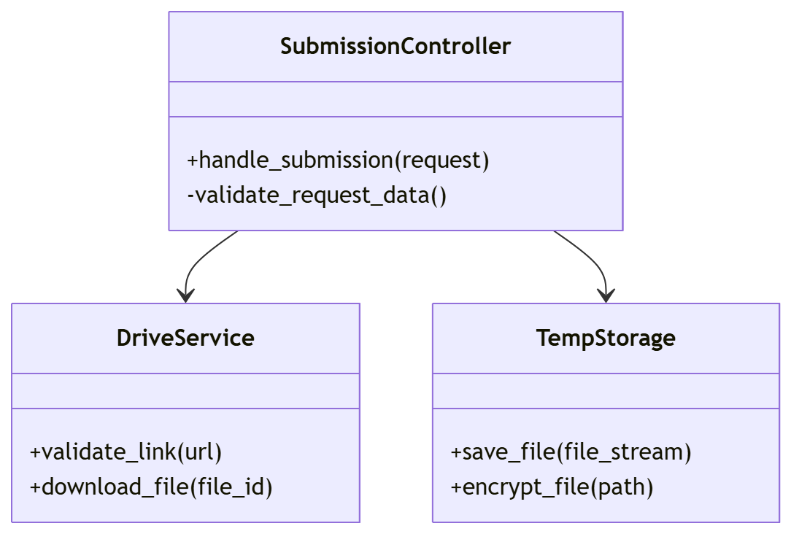

Data Design (ERD/Schema)
- Table: Submissions
  - submission_id (PK, UUID)
  - student_id (VARCHAR)
  - file_source (ENUM: 'UPLOAD', 'DRIVE')
  - status (ENUM: 'QUEUED', 'PROCESSING', 'COMPLETED', 'FAILED')
  - timestamp (DATETIME)

1.2 Transaction: Handle Permission Error
Traceability: Implements M1.UC02.
User Interface Design (Front-end)
- Component Name: ErrorModal.jsx
- Description: Displays specific instructions when a 403 Forbidden error is returned from the backend, guiding the user to change Drive sharing settings.
- Type: React Modal Component.

Back-end Component(s)
- Component Name: PermissionHandler (in DriveService.py)
- Description: Catches googleapiclient.errors.HttpError. If status is 403, raise a custom PermissionDeniedException with a specific error code for the frontend.
- Type: Exception Handler.

Module 2: Metadata Extraction & Content Analysis

2.1 Transaction: Perform Metadata Extraction
Traceability: Implements M2.UC01

Back-end Component(s)

Component Name: DocxParser.py

Description: Uses python-docx to open the file. Extracts Core Properties (author, created, modified) and iterates paragraphs for text content.

Type: Utility Class.

Component Name: AnalysisEngine.py

Description: Orchestrator that calls DocxParser, computes statistics (word/sentence count), and validates completeness (<50 words check).

Type: Service Class.
Object-Oriented Components
Sequence Diagram:

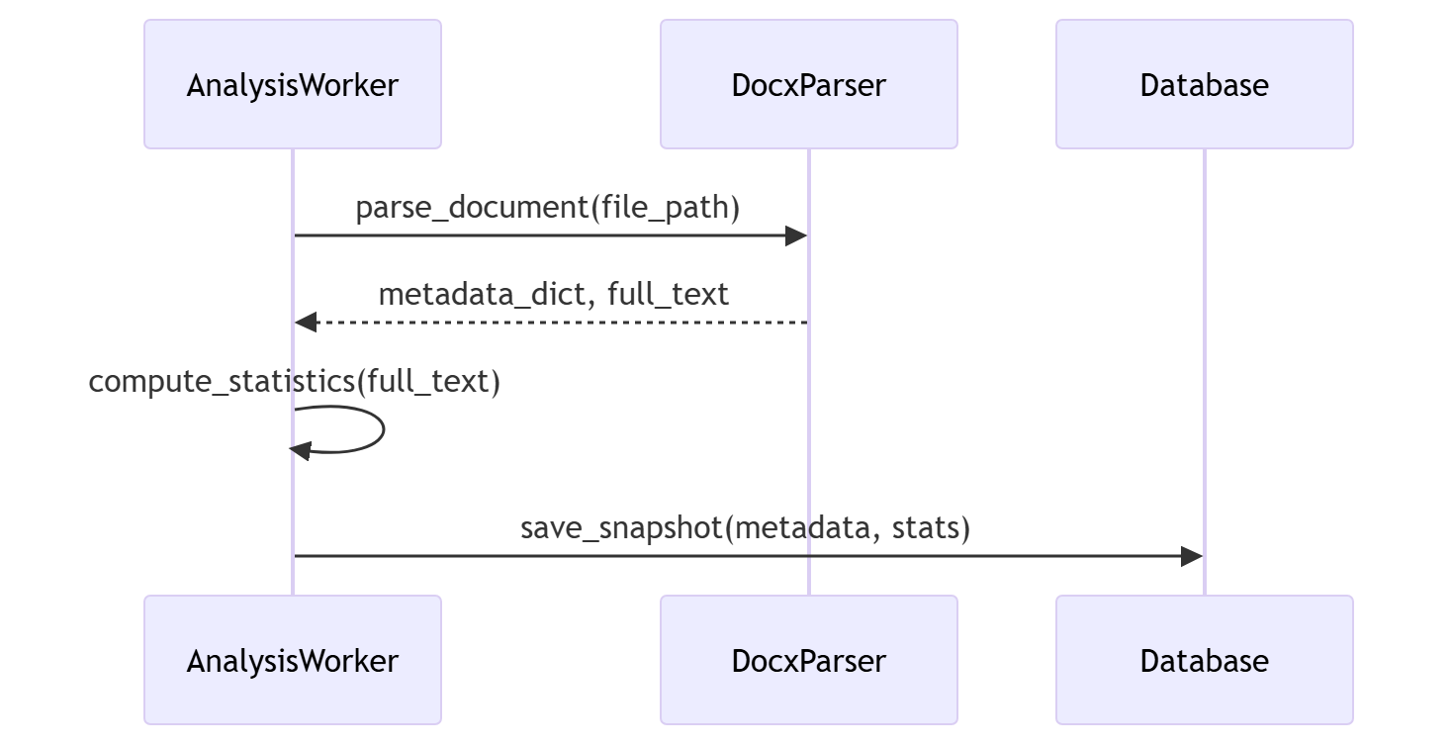

2.2 Transaction: Store Analysis Snapshot
Traceability: Implements M2.UC02.
Data Design (ERD/Schema)
- Table: AnalysisSnapshots
  - snapshot_id (PK, UUID)
  - submission_id (FK -> Submissions)
  - word_count (INT)
  - char_count (INT)
  - metadata_author (VARCHAR)
  - metadata_created (DATETIME)
  - metadata_modified (DATETIME)
  - content_hash (VARCHAR, SHA-256)

Module 3: Rule-Based AI Insights
This module processes the raw metadata extracted in Module 2 and applies deterministic rules to classify submission behavior (e.g., "Late", "Rushed") and track content growth.

3.1 Transaction: Evaluate Timeliness vs. Deadline

Traceability: Implements M3.UC01.
User Interface Design

Note: This is a backend-driven process. Results are displayed in the Dashboard (Module 5).

Front-end Component: InsightBadge.jsx

Description: A reusable UI badge component that conditionally renders labels ("On-Time" [Green], "Late" [Red], "Rushed" [Orange]) based on the status returned by this module.

Type: React Functional Component.

Back-end Component(s)
- Component Name: HeuristicEngine.py
- Description:
  - Retrieves the deadline_id associated with the submission.
  - Fetches the specific due_date from the Deadlines table.
  - Compares the document's last_modified timestamp against the due_date.
  - Applies logic:
    - Late: last_modified > due_date
    - Rushed: (due_date - last_modified) < 1 hour
    - On-Time: All other valid cases.
- Type: Logic Service Class.
Data Design
- Table: HeuristicResults
  - result_id (PK, UUID)
  - submission_id (FK -> Submissions)
  - is_late (BOOLEAN)
  - is_rushed (BOOLEAN)
  - time_diff_minutes (INT)
Object-Oriented Components
Class Diagram: Timeliness Logic
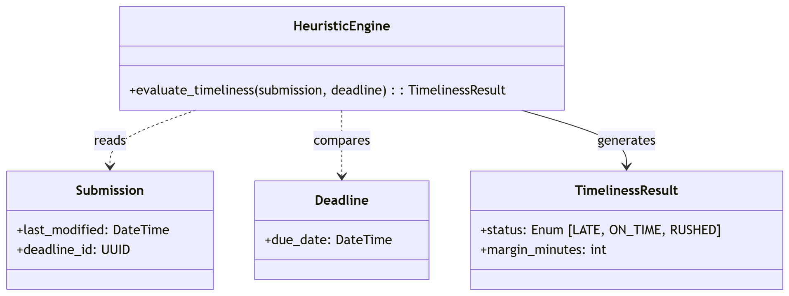
Sequence Diagram: Evaluate Timeliness
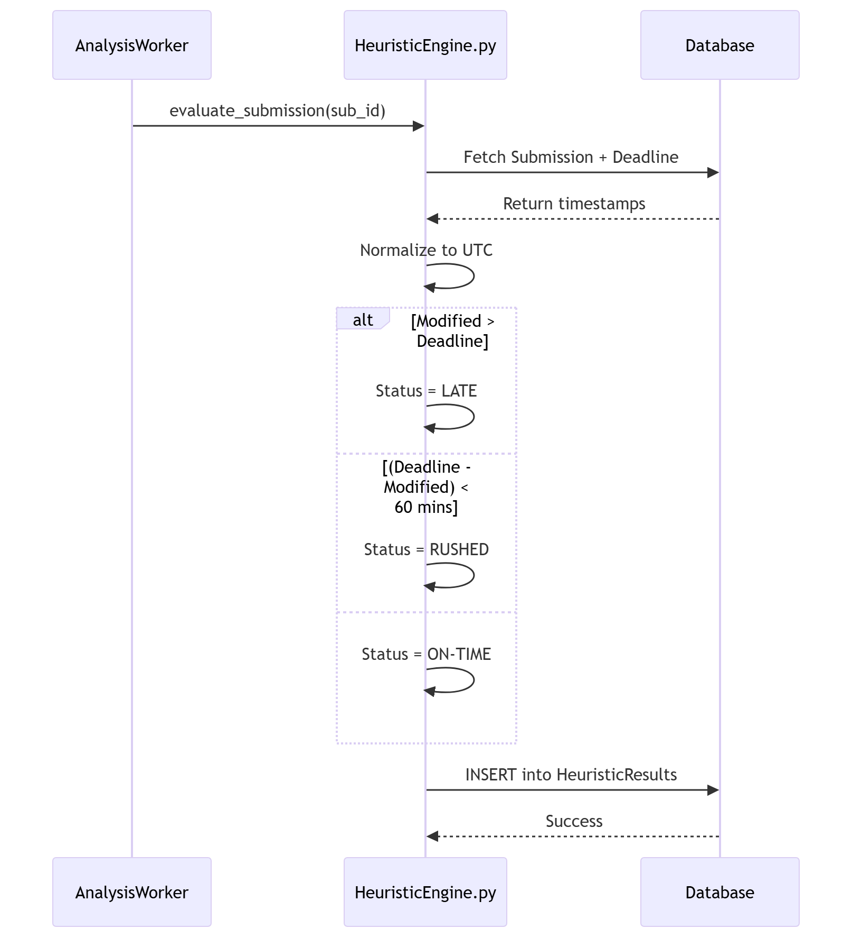

3.2 Transaction: Compute Contribution Growth

Traceability: Implements M3.UC02 (Compute Contribution Growth).

Back-end Component(s)

Component Name: VersionComparator.py

Description:

Queries AnalysisSnapshots to find the most recent previous record for the same file_id (Google Doc ID) or student_id.

If a prior snapshot exists, calculates the percentage change: ((Current - Previous) / Previous) * 100.

Flags "Major Contribution" if growth $\ge$ 50%.

Type: Utility Class.

Data Design

Table: HeuristicResults (Updates existing record)

growth_percent (FLOAT)

previous_snapshot_id (FK -> AnalysisSnapshots, Nullable)

contribution_flag (ENUM: 'MAJOR', 'MINOR', 'NEW')

Object-Oriented Components
Sequence Diagram: Growth Computation
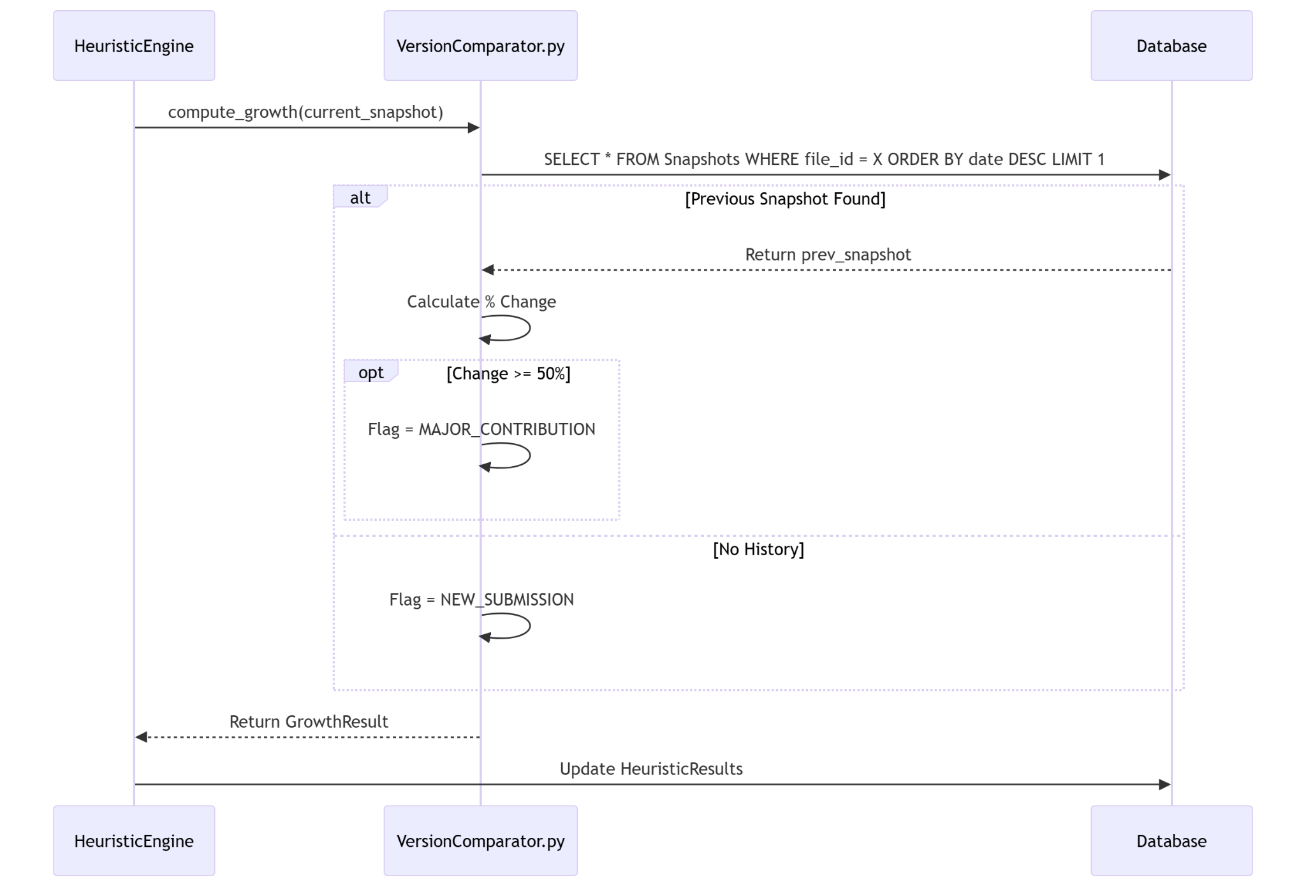
3.3 Transaction: Generate & Persist Heuristic Insights
SRS Reference: Traceability: Implements M3.UC03 (Generate Heuristic Insights).
This transaction consolidates the results from the Timeliness evaluation (Transaction 3.1) and Contribution Growth computation (Transaction 3.2) into a unified, human-readable summary for the professor.
Back-end Component(s)
Component Name: InsightGenerator.py
Description:
- Retrieves the stored HeuristicResults for the specific submission.
- Applies combinatorial logic to generate a natural language summary.
  - Example Logic: IF is_late AND growth > 50% THEN Message = "Submission was late but demonstrates major contribution effort."
  - Example Logic: IF is_rushed AND growth < 10% THEN Message = "Last-minute submission with minimal content changes detected."
- Updates the HeuristicResults table with this summary text and a structured JSON object for frontend rendering.
Type: Logic Service Class.
Data Design
Table: HeuristicResults (Schema Update)
- insight_summary (TEXT) - The human-readable message.
- insight_data (JSONB) - Structured flags for UI highlighting (e.g., {"highlight_color": "red", "priority": "high"}).
- generated_at (TIMESTAMP)
Object-Oriented Components
Class Diagram: Insight Generation
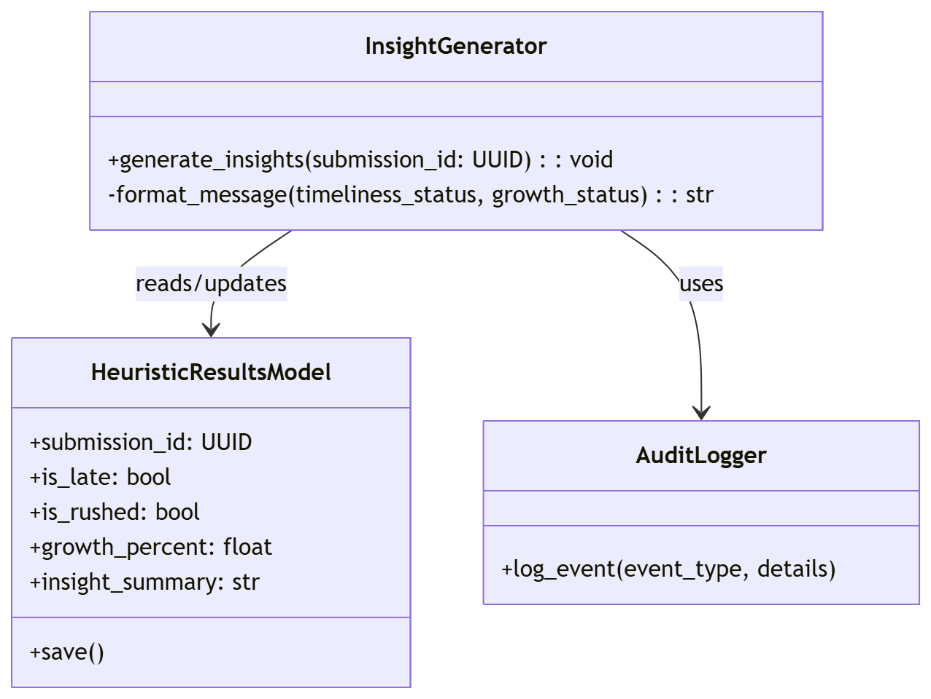
Sequence Diagram: Generate & Persist Insights
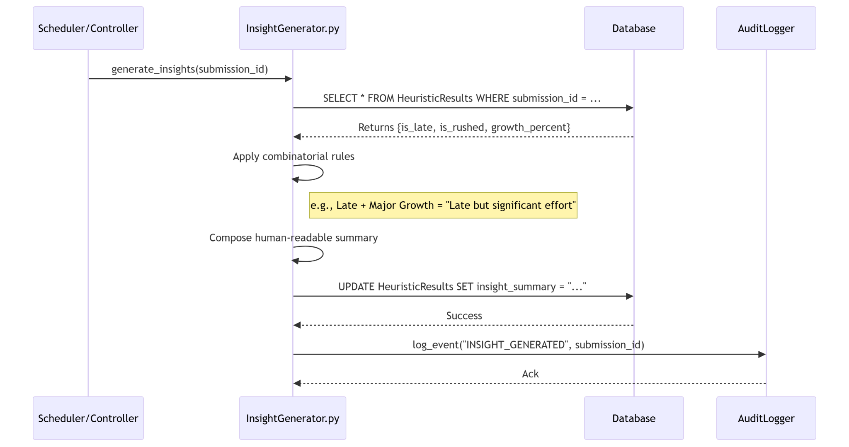

Module 4: NLP-Based Analysis
This module performs computationally intensive linguistic analysis to determine readability scores and generate summaries.

4.1 Transaction: Perform Local NLP Analysis
Traceability: Implements M4.UC01 (Local NLP Analysis).
Back-end Component(s)
Component Name: NLPService.py
Description:
- Tokenization: Uses spaCy (en_core_web_sm) to clean text and remove stopwords.
- Readability: Uses textstat.flesch_kincaid_grade() to calculate the grade level.
- NER: Extracts entities (PERSON, ORG, DATE) to identify key topics.
- Frequency: Uses collections.Counter to find the top 10 non-stopword terms.
Type: Service Class.
Data Design
Table: NLPAnalysis
- analysis_id (PK, UUID)
- submission_id (FK)
- readability_score (FLOAT)
- top_keywords (JSONB) - Stores list of top words.
- entity_counts (JSONB) - Stores map of {PERSON: 3, ORG: 2}.
Object-Oriented Components
Class Diagram: NLP Processing:
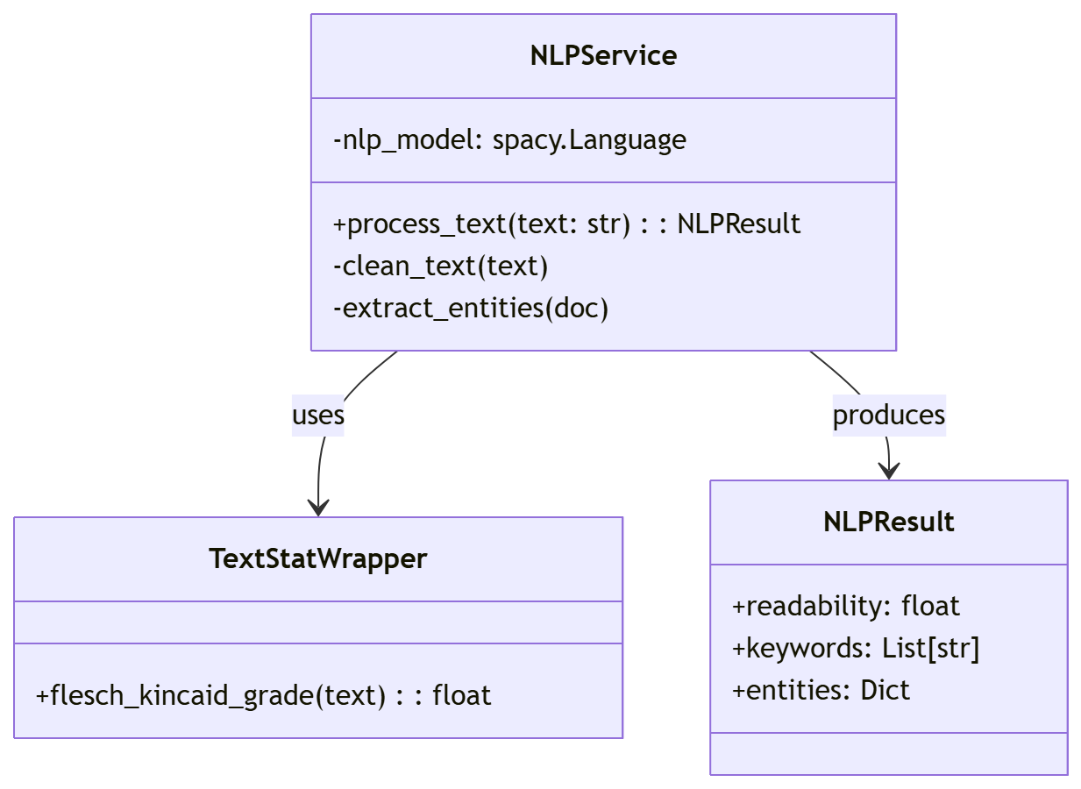

4.2 Transaction: Optional Gemini-Assisted Summary
Traceability: Implements M4.UC02 (External AI Summary).
Back-end Component(s)
Component Name: GeminiClient.py
Description:
    - Sanitization: Accepts the raw text and replaces named entities found in 4.1 (e.g., student names) with placeholders [STUDENT] to ensure data privacy (SRS Constraint ).
    - Request: Sends the sanitized text to Google Gemini API with the prompt: "Summarize this academic paper in 3 sentences."
    - Fallback: Wraps the API call in a try-except block. If the API fails or times out (>15s), returns None (triggering a fallback to local extraction).
Type: API Wrapper / Client.
Object-Oriented Components
Sequence Diagram: AI Summary Generation
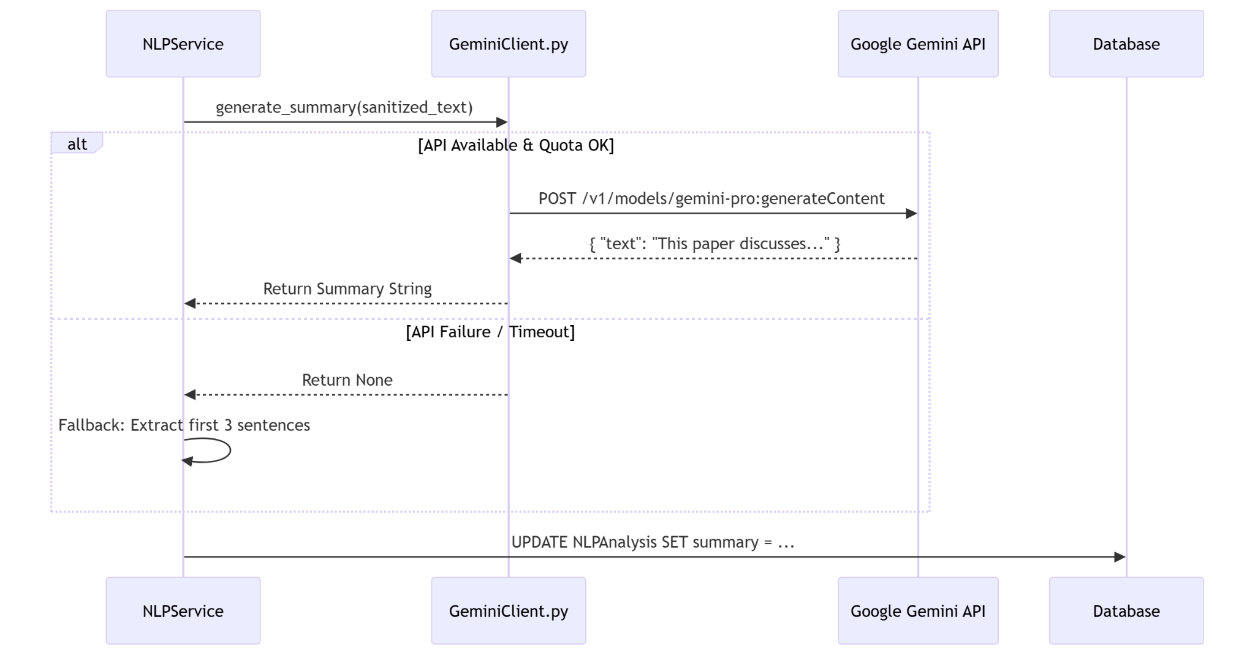
4.3 Transaction: Consolidate NLP Results & Generate Report
SRS Reference: Traceability: Implements M4.UC03 (Consolidate NLP & AI Outputs).
This transaction acts as the synchronization point for Module 4. It waits for the asynchronous completion of both the Local NLP Analysis (Transaction 4.1) and the optional External AI Summary (Transaction 4.2), merges their distinct outputs into a unified JSON structure, and persists the final result for the dashboard to consume.
Back-end Component(s)
Component Name: NLPService.py (Method: consolidate_results)
Description:
- Retrieval: Fetches the local_analysis_results (keywords, readability, entities) and ai_summary_text (if enabled/available) from the database or temporary cache.
- Merging: Constructs a unified dictionary:
{
"readability": { ... },
"entities": { ... },
"keywords": [ ... ],
"ai_summary": "The generative summary...",
"status": "COMPLETED"
}
- Validation: Checks if the AI summary failed (is null) and inserts a standard fallback message if necessary.
- Persistence: Serializes the dictionary to JSONB and updates the NLPAnalysis table.
Type: Service Logic.
Data Design
Table: NLPAnalysis (Updates existing record)
- consolidated_report (JSONB) - The final merged output used by the frontend.
- completed_at (TIMESTAMP)
- status (ENUM: 'PENDING', 'COMPLETED', 'PARTIAL_FAILURE')

Object-Oriented Components
Class Diagram: Result Consolidation
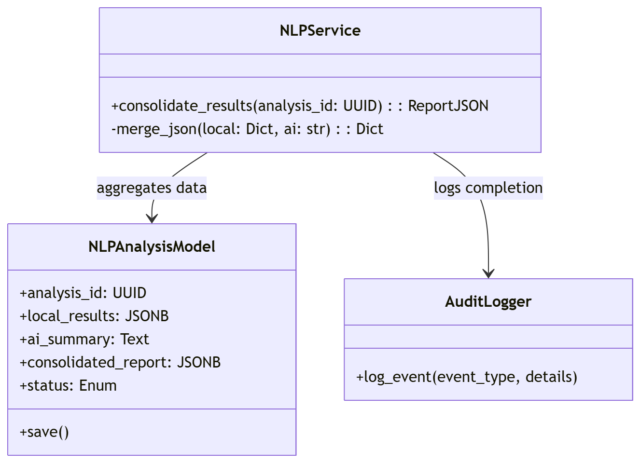

Sequence Diagram: Consolidate & Persist
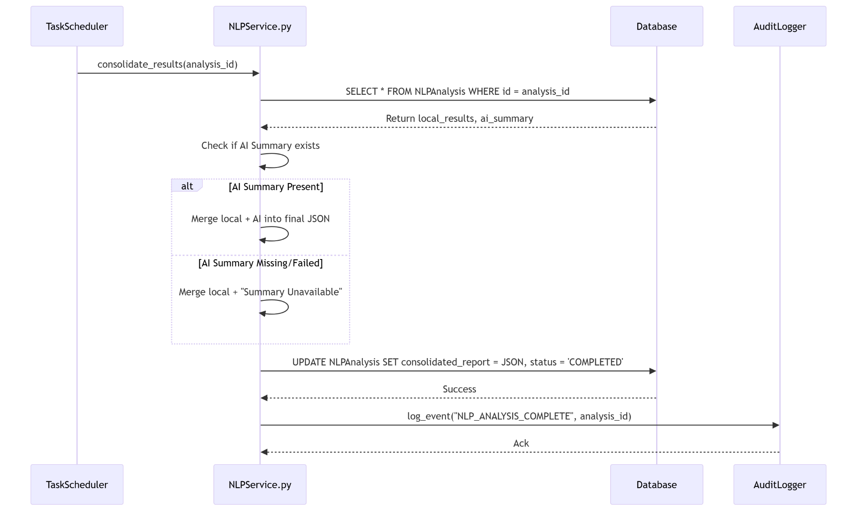

Module 5: Dashboard & Link Generation
This module serves as the primary interface for professors, handling secure authentication, deadline management, report viewing, and the generation of deadline-specific submission links.

5.1 Transaction: Professor Login (Gmail OAuth 2.0)
Traceability: Implements M5.UC01 .
- User Interface Design
  - Front-end Component: LoginButton.jsx
  - Description: A "Sign in with Google" button that initiates the OAuth 2.0 flow. It redirects the user to the Google Authorization Server.
  - Type: React Functional Component.
- Back-end Component(s)
  - Component Name: OAuthController.py
  - Description: Handles the callback from Google (/auth/google/callback).
    - Exchange the authorization code for an ID Token.
    - Decodes and verifies the token signature.
    - Checks the hd (hosted domain) claim against the allowed institutional domain (e.g., @cit.edu).
    - If valid, establish a secure server-side session.
  - Type: Flask Controller.
Object-Oriented Components
Sequence Diagram: OAuth Login
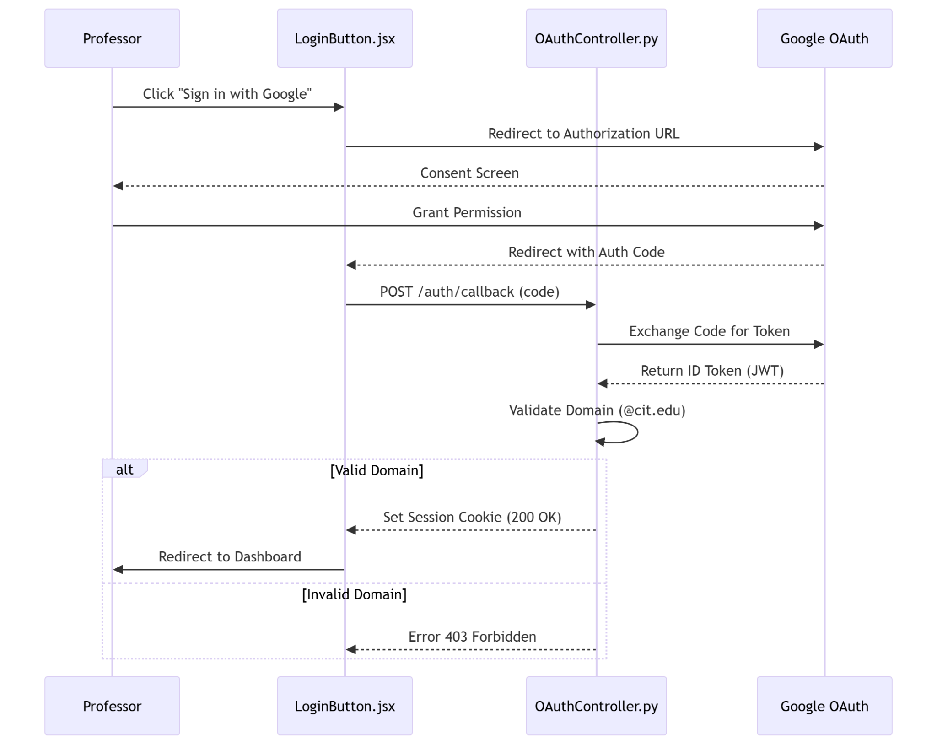

5.2 Transaction: Create/Edit Submission Deadline
Traceability: Implements M5.UC02 .
- User Interface Design
  - Front-end Component: DeadlineManager.jsx
  - Description: A form interface listing existing deadlines. Allows creation/editing of "Assignment Title", "Date", and "Time". Includes validation to prevent selecting past dates.
  - Type: React View.
- Back-end Component(s)
  - Component Name: DeadlineController.py
  - Description: POST /api/deadlines. Validates input formats and ensures logical consistency (e.g., date > now). Saves the deadline record used by Module 3 for "Late" vs "On-Time" classification.
  - Type: Controller.

- Data Design
  - Table: Deadlines
    - deadline_id (PK, UUID)
    - professor_id (FK -> Users)
    - title (VARCHAR)
    - due_date (TIMESTAMP WITH TIME ZONE)
    - created_at (TIMESTAMP)
Object-Oriented Components
Class Diagram: Deadline Management
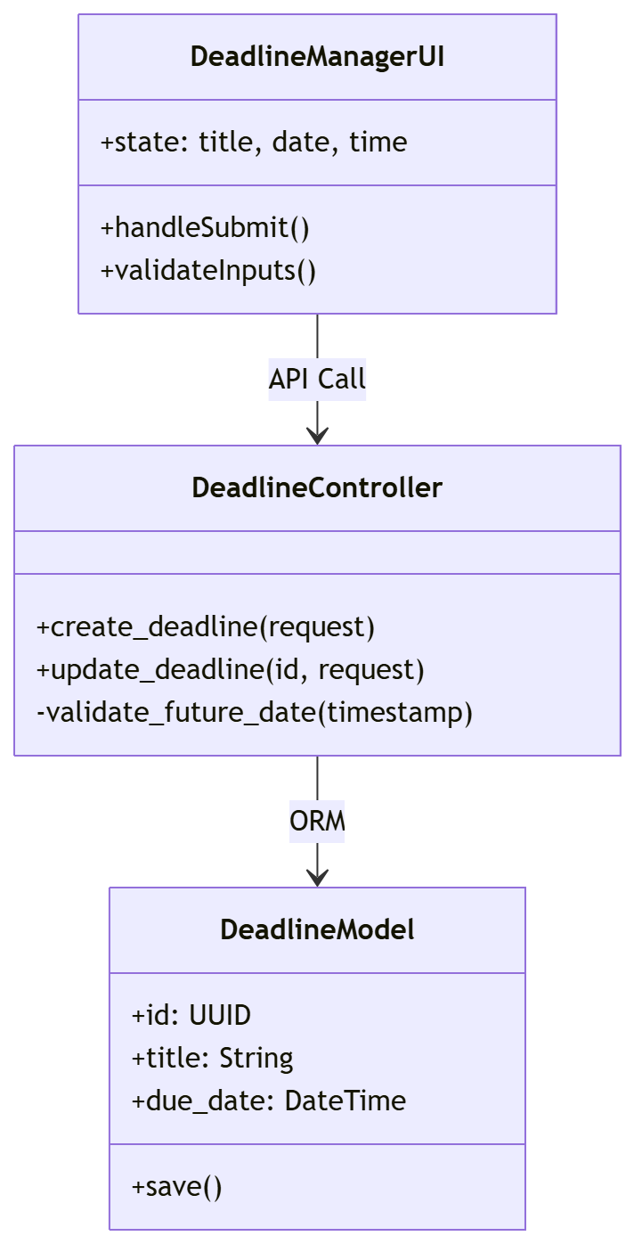

5.3 Transaction: Submission Link Generation
Traceability: Implements M6.UC03 .
- User Interface Design
  - Front-end Component: LinkGenerator.jsx
  - Description:
    - Fetches and displays a dropdown of active deadlines from DeadlineManager.
    - On "Generate Link" click, sends the selected deadline_id to the backend.
    - Displays the returned secure URL (e.g., https://system.edu/submit/<token>) for the professor to copy.
  - Type: React Component.
- Back-end Component(s)
  - Component Name: LinkController.py
  - Description:
    - Receives deadline_id.
    - Validates that the deadline exists and has not expired.
    - Generates a cryptographically secure random token (UUID4).
    - Stores the token mapping in the database.
  - Type: Controller.
- Data Design
  - Table: SubmissionLinks
    - link_token (PK, VARCHAR)
    - deadline_id (FK -> Deadlines)
    - created_by (FK -> Users)
    - expires_at (TIMESTAMP) - Mirrors the deadline date

Object-Oriented Components
Sequence Diagram: Generate Link
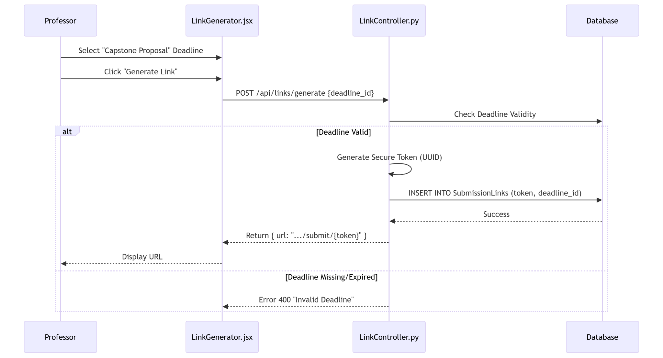

5.4 Transaction: View Submission Report
Traceability: Implements M5.UC04 .
- User Interface Design
  - Front-end Component: ReportCard.jsx
  - Description: A dashboard widget that visualizes a single submission's data.
    - Metadata: Displays Author, Created Date, Word Count.
    - Heuristics: Renders status badges (e.g., "Late" in Red, "Major Contribution" in Green).
    - NLP: Shows readability score and AI summary text.
  - Type: React View.
- Back-end Component(s)
  - Component Name: ReportController.py
  - Description: GET /api/reports/{submission_id}. Performs a join query across Submissions, AnalysisSnapshots, HeuristicResults, and NLPAnalysis tables to construct a complete JSON response.
  - Type: Controller.

Object-Oriented Components
Sequence Diagram: View Report
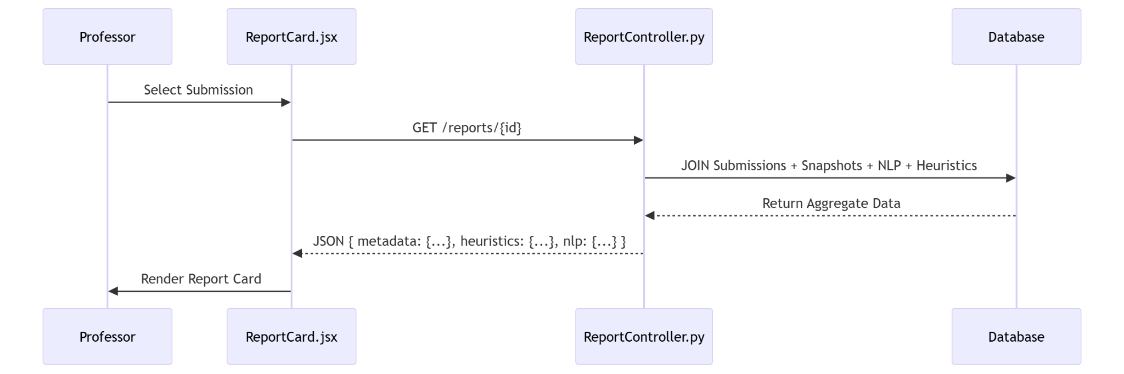

5.5 Transaction: Export Report (PDF/CSV)
Traceability: Implements M5.UC05 .
- User Interface Design
  - Front-end Component: ExportButton.jsx
  - Description: A split button allowing the user to select "Export as PDF" or "Export as CSV". Triggers a file download.
  - Type: React Component.
- Back-end Component(s)
  - Component Name: ExportService.py
  - Description:
    - PDF: Uses reportlab to draw a structured document containing the Report Card data.
    - CSV: Uses Python's csv module to flatten the hierarchical report data into a tabular format.
    - Returns a file stream with the appropriate MIME type (application/pdf or text/csv).
  - Type: Service Class.

Object-Oriented Components
Class Diagram: Export Logic
